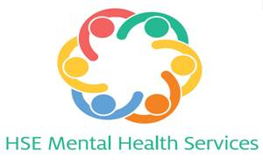

PRIMERA Timeline for the Implementation and Evaluation of Family Talk
We hope this timeline acts as a helpful reminder to you when considering the implementation of Family Talk at each site. We fully understand the challenges that lie ahead and that these may vary among sites. If at any stage you think that you may not be able to meet a deadline, please contact Mairead or Christine immediately who will advise accordingly.

- June 2018 - recruit staff to facilitate family talk
  - Consider staff holidays and how this might impact your planning
- July 2018 - All staff to complete Family Talk training
- August 2018 - Begin identifying and recruiting families
- August 2018 - Conference in Drogheda
- September 2018 - Potential training day face-to-face or online
  - screen families for suitability
- October 2018 - PRIMERA researchers begin collecting data
  - Consider school holidays and how this will impact family availability
- November 2018 – Staff to deliver Family Talk to families
- December 2018 – Staff to deliver Family Talk to families
  - Christmas break staff and families
- January 2019 - Recommence after the Christmas Break
- September 2019 – Final enrolment of families to Family Talk
- March 2020 – Sites to complete Family Talk with control families recruited in September 2019

